ATICS-

Automated Toolbox Inventory Control System

Prototype

Null Terminators





Senior Project Requirement Specifications

CptS 421/423

WSU Tri-Cities

1710 Crimson Way, Richland, WA 99354

**Title:**

Automated Toolbox Inventory Control System

**Project Team:**

Null Terminators

**Participants:**

Reem Osman (Project Manager)

Caitlyn Powers

Steven Pixler

Navin Sabandith

Caleb Thomas

**Client:**

Troy Stokes, HiLine Engineering

**Client Technical Contact:**

Andrew Tolman, HiLine Engineering

**Supervisor:**

Dr. Neil Corrigan, WSUTC

**Table of Contents**

1.0 FlowChart 4

2.0 Program Operation Overview Diagram 5

Refer to the design document for up to date program operation 5

3.0 Prototyping 6

3.1 Database Prototype 6

3.2 Test Mode Prototype Output 7

3.3 Record Mode Prototype Output 8

3.4 Problems caused by shadows 9

4.0 Configuration files 9

4.1 Variables in the global configuration file: 9

4.2 Variables in the drawer configuration file (stored in the database): 10

**5.0 Camera research 10**

# 1.0 FlowChart

(Zoom in on browser to inspect)

# 

# 

# 

# 

# 

# 

# 2.0 Program Operation Overview Diagram

*Refer to the design document for up to date program operation*

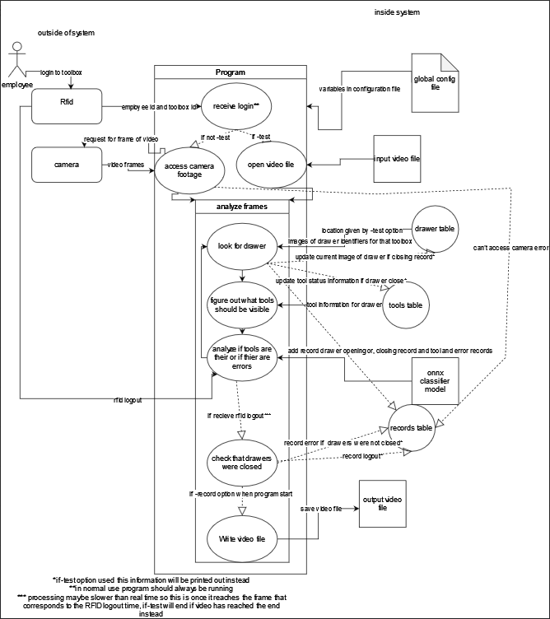

# 3.0 Prototyping

## 3.1 Database Prototype

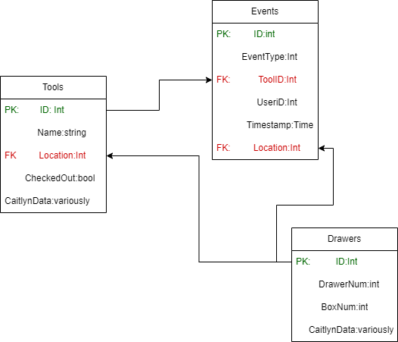

The figure above shows the proposed layout of tables and data fields within the database - typically referred to as a *schema*

* 3 primary tables - Tools, Events, and Drawers
* Tools table
  + ID - unique integer value identifying a particular tool, Called the *primary key*
  + Name - The human readable name of the tools, stored as a string
  + Location - an int value identifying a particular drawer within a particular toolbox. This value is called a *foreign key,* as this is the primary key ID of a drawer entry in the drawers table
  + CheckedOut - called a *bool*, this value can either be true or false, reflecting whether or not the tool is currently in the drawer
  + CaitlynData - a placeholder type, there will be some additional data like pictures of the drawers, and similar information. More experimentation is required to determine the exact layout of this field, but HiLine should expect to see an amount of data stored here in support of the camera system
* Events table
  + ID - unique integer value identifying a particular event record. The *primary key* of this table
  + EventType - an integer value identifying what information is conveyed by the record. Is the tool being checked out? Returned? Was a drawer opened? Closed? Etc. A map of these types will be provided in the documentation as well as in the API utility
  + ToolID - int value, a foreign key listing which tool from the tools table is being manipulated by the record
  + UserID - int or alphanumeric value - the unique employee ID provided by the API triggers given from HiLine’s authentication and prox card system
  + Timestamp - the time at which the event occurred
  + Location - int value, a foreign key from the drawers database which identifies which drawer and in which box an event occurred in
* Drawers Table
  + ID - unique integer value identifying a particular drawer and toolbox combination. The primary key of this table
  + DrawerNumber - integer value identifying the number assigned to a manipulated drawer
  + BoxNum - integer value identifying the toolbox being manipulated
    - Collapsing both of these numbers into one ID field allows for faster searches for all tools or activity in a particular drawer, as only one column must be searched in the tools or events database.
  + CaitlynData - a placeholder type, there will be some additional data like pictures of the drawers, and similar information. More experimentation is required to determine the exact layout of this field, but HiLine should expect to see an amount of data stored here in support of the camera system

## 3.2 Test Mode Prototype Output

Outputted records will be in chronological order.

Opened: Toolbox <toolbox identifier> Drawer <toolbox identifier>: <time> <employee id>

Tools checked out:

<Tool identifier> <employee id> <time> <location>

. . . (repeat for each tool checked out

Tools checked in:

<Tool identifier> <employee id> <time> <location>

. . . (repeat for each tool checkout)

Error:

<error type> <tool identifier> <employee id> <time> <location>

. . . (repeat for each tool checkout)

Closed: Toolbox <toolbox identifier> Drawer <toolbox identifier>: <time> <employee id>

… (repeat for each opening of drawer)

## 3.3 Record Mode Prototype Output

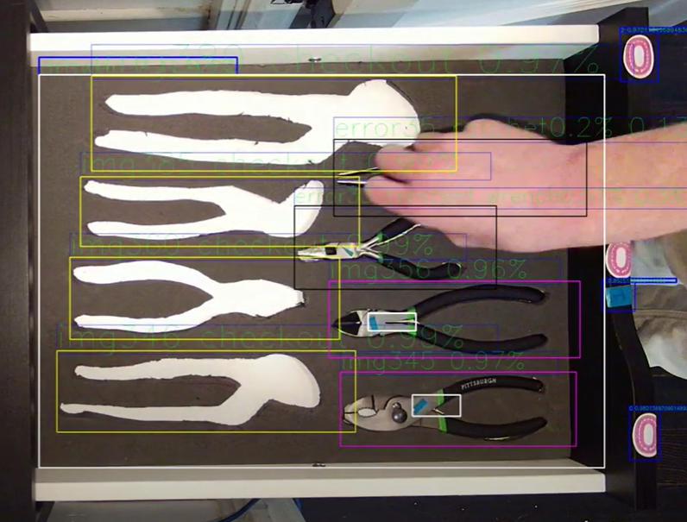

A Magenta box means tool is checked in, a yellow box means tool is checked out, black means error - wrong tool.The large white box shows the outline of the recognized drawer and the smaller white boxes indicate drawer symbols. Blue boxes outline both drawer symbols and extra tools. If there is no tool in a tool location, the label will say “checkout”. If there is an error the label will say error and then the tool ID number.

## 3.4 Problems caused by shadows

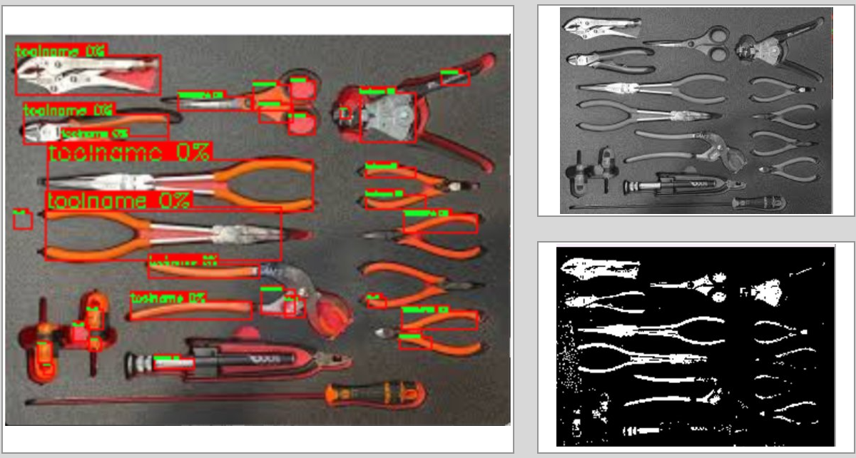

The above photos show an example of a drawer that is difficult to process effectively. The glare in the top left corner, as well as the shadow in the bottom right corner adds complexity to the detection process, and the primary method of determining the presence of a tool may not be effective. The tools with black handles overlayed on the black background also pose issues for the traditional method. Matching tools by their engraved unique character should continue to function, but detection speed and accuracy will be greatly improved by more consistent lighting.

# 

# 

# 4.0 Configuration files

## 4.1 Variables in the global configuration file:

* Rtsp link for each toolbox
* File location of onnx classifier
* Port for RFID trigger listener
* Image file normalization variables for classifier
* Database location/access information
* Location to save video files when using record mode option
* Similarity threshold for template matching (decides whether or not someone's hand or head is in the way)
* Location +- in drawer int value for the allowable difference from stored location values
* Size +- in drawer int value for the allowable size difference from stored width and height values
* More variables may be added

## 4.2 Variables in the drawer configuration file (stored in the database):

* Cv2 enum int value to turn picture into grayscale
* Cv2 enum int value for threshold type
* Cv2 enum value for finding contours
* Int value for the threshold
* Int value for Minimum width of object in pixels
  + Should at least be 1
* Int value for Minimum height of object in pixels
  + Should be at least 1
* Int value for which picture tool location in drawer information comes from
  + 0 = no tools image
  + 1= tools image
  + -1 = neither ( location in the picture was found manually, so do not segment drawer)
  + 2 = both (ie going through the algorithm every segmentation in both match up)
* More variables may be added

# 5.0 Camera research

* Minimum camera requirements
  + Illumination
    - 1 lux
      * Will probably still want a light specifically for the camera for consistency.
    - It should also be noted that all the cameras the team found were true wide-range which means that they can capture a larger spectrum of lighting conditions.
  + Lens
    - Field of view
      * The vast majority of cameras should be fine, it really just determines how far away the camera needs to be, the wider the viewing angle the closer it can be. This means the less likely it is for someone to have their head in the way the entire time. So less than 130 more than 80.
  + Resolution
    - 2 mp
      * The more resolution typically the better, but in the end looking at the license plate pictures, the bottom drawer should be about 5 times the width and 4.8 times the height times the size of that license plate using the given measurements, with the plate being about 100 x 50 pixels on a 2 MP camera which times 5 and 4.8 would be 120,000 pixels. An 8 mp camera in comparison will be about 200 x 100 so about 480,000. A smaller viewing angle makes it a little bit wider, but we will also have to move it farther away from the box. So an 8 mp is unmistakably better, but a 2mp camera should still theoretically work.
      * 130* 49/(120,000) =.053
      * It should also be noted that for debugging an 8mp or greater camera is desired since the minimum text thickness and bounding boxes are 1 pixel.
  + Protocols
    - RTSP
  + Other
    - The camera should not automatically zoom or move. If a camera has these features, it must have the ability to turn the features off.
    - To help facilitate the digital image recognition process, small objects should be placed in drawers near the top of the toolbox when possible. This allows the computer vision system to have the best possible chance at recognizing the tool quickly and accurately.